1. For this practical we required **MongoDB, postman & VSCode** install on your computer
2. Create empty folder Ass_3B and open this folder in VSCode
3. For this practical we need package.json, so we run following cmd command :

npm init -y

npm install mongodb //Note : it is for installing monogdb inside the project

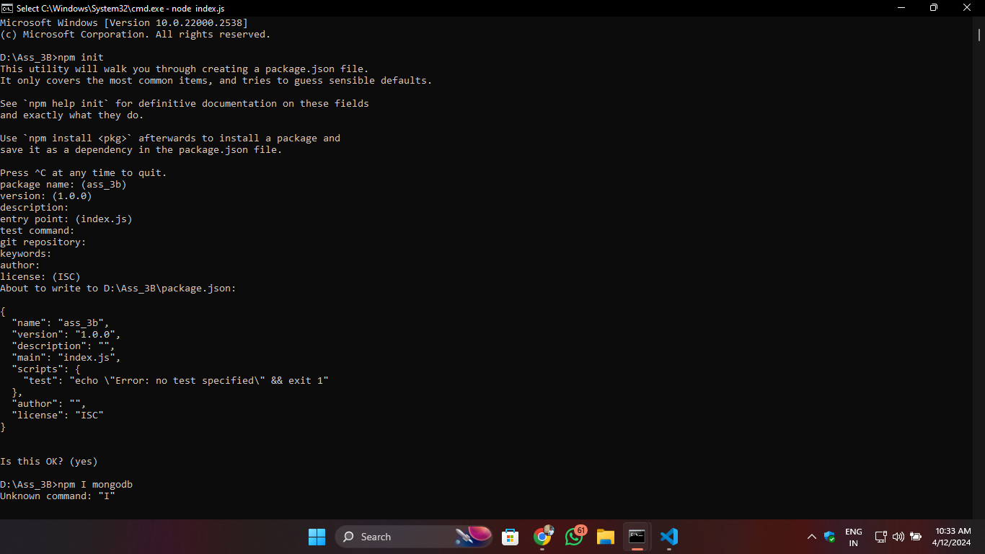npm install express

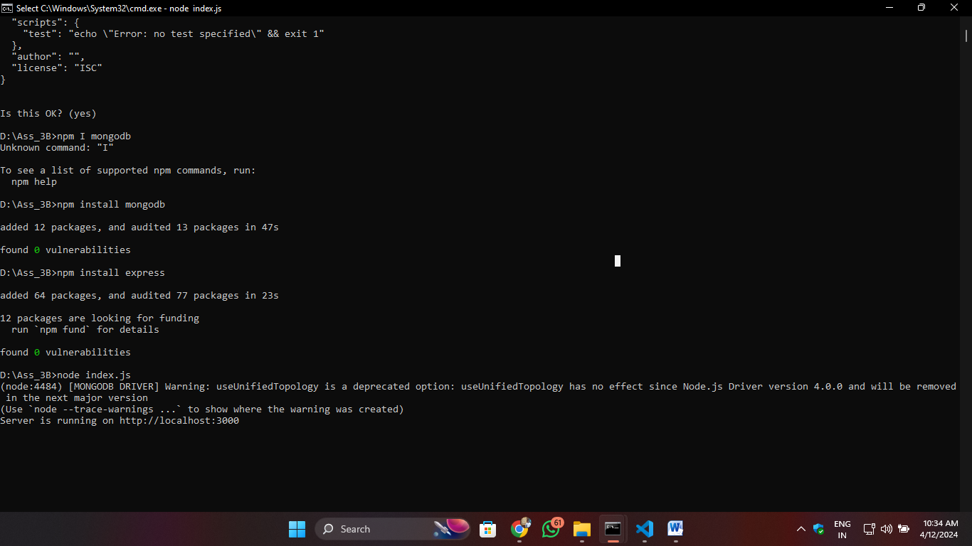

1. Create file index.js file in Ass_3B

Write the below code:

const dbConnect = require('./mongodb');

const express = require('express');

const app = express();

app.use(express.json())

// GET API

app.get('/', async (req, res) => {

    try {

        const collection = await dbConnect(); // Connect to MongoDB

        const result = await collection.find().toArray(); // Query the collection

        res.send(result); // Send response

    } catch (error) {

        console.error('Error:', error); // Log any errors

        res.status(500).send('Internal Server Error'); // Send a generic error response

    }

});

//post API

app.post('/',async(req,res)=>{

    let result = await dbConnect();

    result = await result.insertOne(req.body);

    res.send("Data Inserted Successfully")

});

//put API

app.put('/:Name',async(req,res)=>{

    let result = await dbConnect();

    result = await result.updateOne({name:req.params.name},{$set:req.body});

    res.send("Data updated Successfully")

});

// delete API

app.delete('/:Name',async(req,res)=>{

    let result = await dbConnect();

    result = await result.deleteOne({name:req.params.name});

    res.send("Data deleted Successfully")

});

const PORT = 3000;

app.listen(PORT, () => {

    console.log(`Server is running on http://localhost:${PORT}`);

});

1. Create file mongoDB.js file in Ass_3B

Write the below code:

const { MongoClient } = require('mongodb');

const url = "mongodb://localhost:27017";

const database = 'college';

const client = new MongoClient(url, { useUnifiedTopology: true });

const dbConnect = async () => {

    try {

        await client.connect(); // Connect to MongoDB

        const db = client.db(database); // Select the database

        return db.collection('IT'); // Return the collection

    } catch (error) {

        console.error('Error:', error); // Log any errors

        throw error; // Re-throw the error to be handled by the caller

    }

};

module.exports = dbConnect;

**//note: My database is “college” and collection is “IT”**

1. 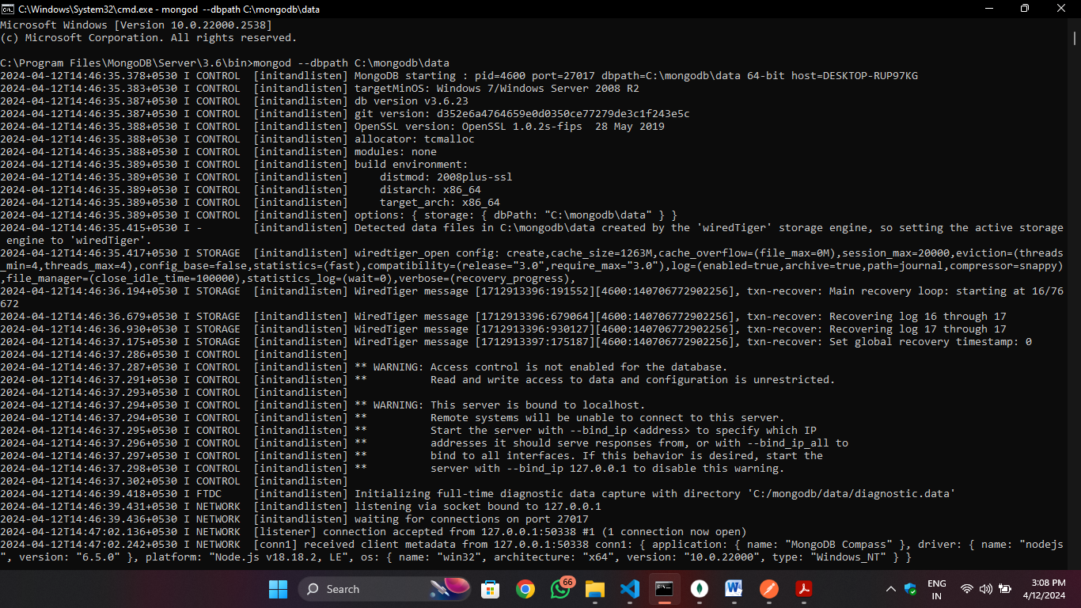I have installed MongoDB 3.6 version (Command Line) for serverRun the server it will listen for client on **port 27017**
2. **Go to MongoDB compass and connect following link and click connect button**

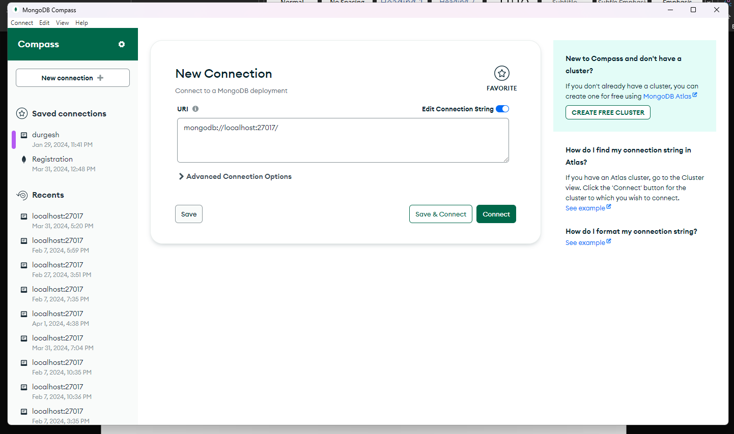Link = ( mongodb://localhost:27017 )

8. To run code, open cmd for that folder then following cmd command enter :

**>node index.js**

**Open Postman app**

**Click New 🡪 HTTP 🡪 Paste the** [**http://localhost:3000**](http://localhost:3000) **link for API Testing**

**POST:**

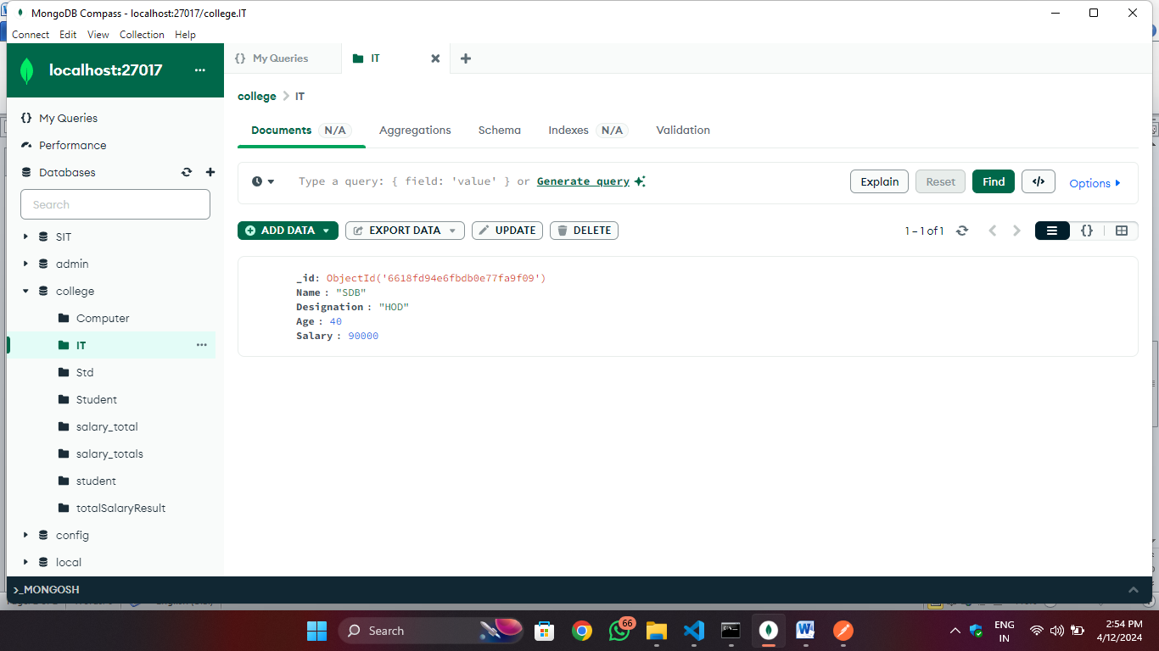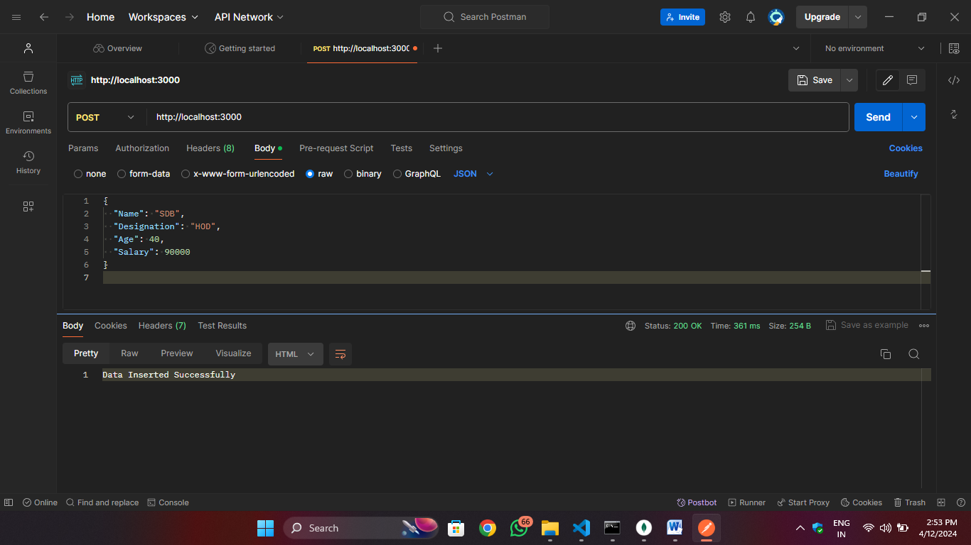

**GET:**

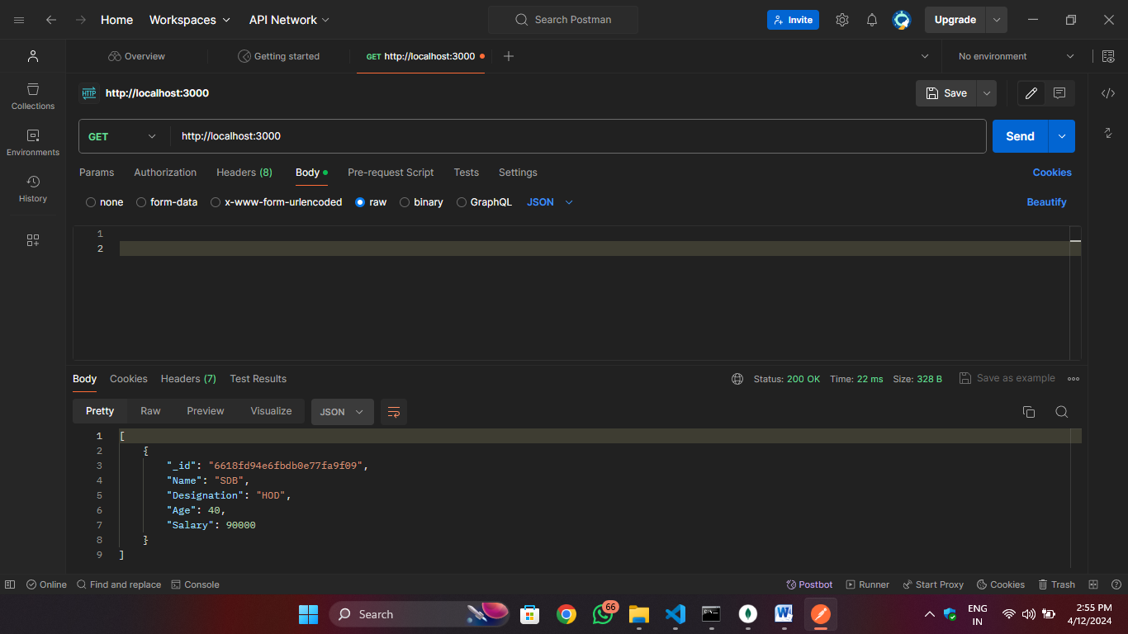

**PUT:** Changed the designation of collection

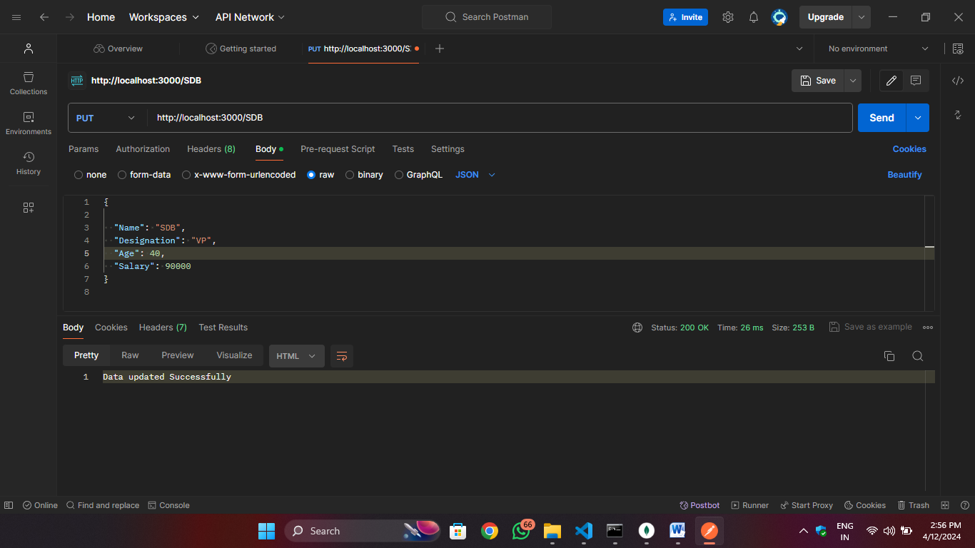

**DELETE:**

